CUSTOMER SHOPPING BEHAVIOR ANALYSIS
Business Problem Statement
A leading retail company seeks to better understand customer shopping behavior in order to improve sales performance, customer engagement, and long-term customer retention. The company has collected transactional data containing customer demographics, purchasing habits, product preferences, subscription status, seasonal shopping trends, and customer reviews.
To support data-driven decision-making, the management team requires an analysis that identifies purchasing patterns, customer segments, and factors influencing shopping behavior.
This project analyzes the customer shopping behavior dataset using Python for data preparation and exploratory analysis, PostgreSQL for structured business queries, and Power BI for dashboard development. The insights generated from this analysis will enable stakeholders to improve marketing strategies, optimize product offerings, strengthen customer engagement, and support business growth.

Deliverables
The project consists of the following deliverables:
1. Data Preparation, Cleaning and Modelling (Python)
Prepared the dataset by inspecting its structure, handling missing values, standardizing column names, engineering new features, and ensuring the data was suitable for analysis.
2. Database Integration and SQL Analysis (PostgreSQL)
Loaded the cleaned dataset into PostgreSQL and executed SQL queries to answer key business questions and extract actionable insights.
3. Interactive Dashboard (Power BI)
Developed an interactive dashboard to visualize important business metrics, customer behavior, and purchasing trends.
4. Project Documentation
Documented the complete analytical process, including data preparation, exploratory analysis, SQL findings, dashboard visualizations, business insights, and recommendations.
5. GitHub Repository
Organized all project files, including the Jupyter Notebook, SQL scripts, Power BI dashboard, and project documentation in a structured GitHub repository.

Project Overview
This project examines customer shopping behavior using a retail transaction dataset containing customer demographic information, purchasing activities, product preferences, subscription status, seasonal trends, and customer review ratings. The objective of the analysis is to uncover insights into spending patterns, customer segments, product preferences, and subscription behavior to guide strategic business decisions.
The findings from this project provide valuable information that can assist stakeholders in understanding customer purchasing behavior and support more informed marketing and product decisions.

Dataset Summary
- Dataset Name: Customer Shopping Behavior Dataset
- Rows: 3,900
- Columns (Original):18
- Dataset Shape:(3900, 18)
- Key Features
- Customer demographics (Customer ID, Age, Gender, Location)
- Product information (Item Purchased, Category, Size, Color)
- Purchase details (Purchase Amount, Previous Purchases, Frequency of Purchases)
- Customer engagement (Subscription Status, Discount Applied, Promo Code Used)
- Shopping behavior (Season, Shipping Type, Payment Method, Review Rating)
- Missing Data: Initial inspection showed 37 missing values in the Review Rating column. These missing values were handled during the data cleaning stage using the median review rating within each product category.

Dataset Structure
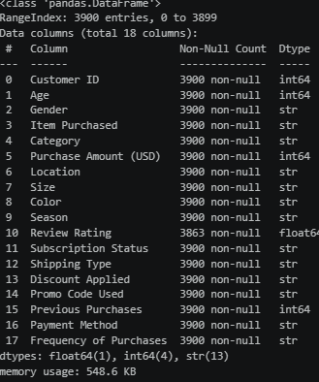
Figure 1: Output of df.info()

Summary Statistics
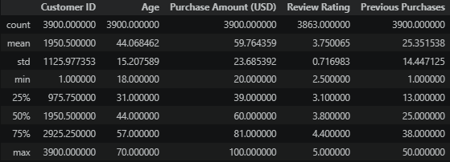
Figure 2: Output of df.describe()

Sample Dataset
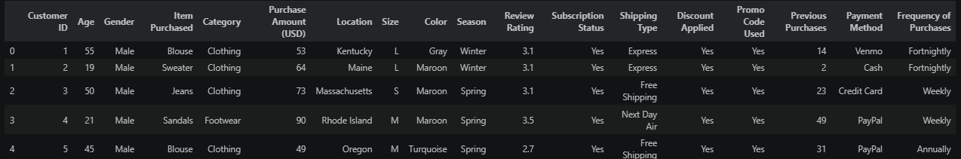
Figure 3: Output of df.head()

DATA CLEANING and Exploratory Data Analysis (EDA)
- Missing Values: The inspection revealed that only the Review Rating column contained missing values, with 37 missing records, while all other variables were complete.
To preserve the dataset and avoid unnecessary data loss, the missing review ratings were imputed using the median review rating within each product category. This approach maintains the central tendency of customer ratings while accounting for differences across product categories.
- Duplicate Records: There were no duplicate records in the dataset
- Column Standardization: column names were standardized using the snake_case naming convention to improve readability and simplify coding.
- Redundant Variable Check: A consistency check was performed to determine whether the Discount Applied and Promo Code Used columns contained identical information, the Promo Code Used column was removed
- Feature Engineering:
- Labels column were created for the different age groups
- Created purchase_frequency_days column from the frequency_of_purchase column
- Database Integration: Connected Python script to PostgreSQL and loaded the cleaned DataFrame into the database for SQL analysis.

DATA ANALYSIS USING SQL
The cleaned data was loaded into PostgreSQL for structured analysis to answer key business questions
- Revenue Generated by Gender: Calculated the total purchase amount generated by male and female customers
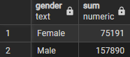
Figure 4: Revenue by Gender Query Result
- High Spending Discount User: To identify high-value customers who remain active even when promotions are offered.
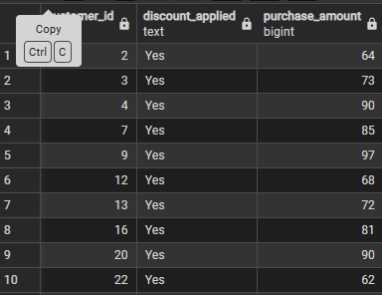
Figure 5: High-Spending Customers Using Discounts
- Top Five Products by Rating: Identify the highest-rated products.

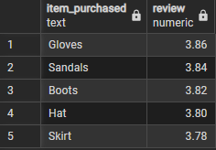
Figure 6: Highest Rated Products
- Average Purchase Amount by Shipping Type: Compared the average purchase amount between Standard and Express shipping
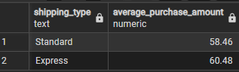
Figure 7: Average Purchase Amount by Shipping Type
- Spending Behaviour of Subscribers and Non-Subscribers: Evaluates the purchasing behaviour of subscribed and non-subscribed customers using average spend, total customer and total revenue
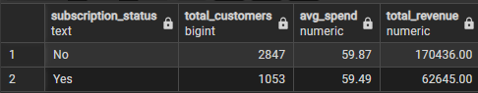
Figure 8: Subscription Status Analysis
- Discount Dependent Product: identify the five products with the highest discount usage.
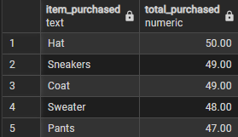
Figure 9: Products Most Frequently Purchased with Discounts
- Customer Segmentation Based on Previous Purchases: Classify customers into three groups based on their purchase history.
- New: 1 previous purchase
- Returning: 2–10 previous purchases
- Loyal: More than 10 previous purchases
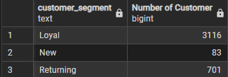
Figure 10: Customer Segmentation
- Top Three Most Purchased Products in Each Category: The top three products in every category.
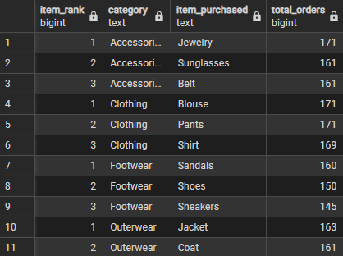
Figure 11: Top Products by Category
- Subscription Status of Repeat Buyers: Identified customers with more than five previous purchases and grouped them according to their subscription status to determine whether repeat buyers are more likely to subscribe.
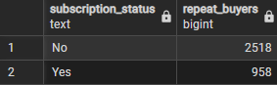
Figure 12: Repeat Buyers and Subscription Status
- Revenue Contribution by Age Group: The total revenue generated by each age group and ranked the groups according to their revenue contribution.
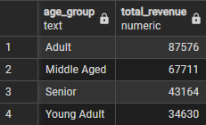
Figure 13: Revenue Contribution by Age Group
POWER BI DASHBOARD
The dashboard combines key performance indicators (KPIs) with interactive charts and filters, enabling users to explore purchasing patterns, customer demographics, product performance, and spending trends.
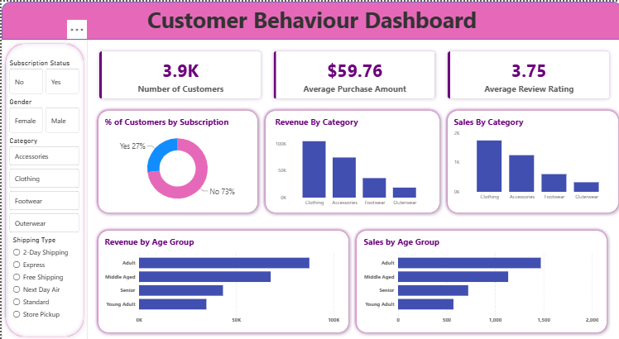
Figure 14: Customer Shopping Behavior Dashboard

KEY FINDINGS
Based on the Python analysis, SQL queries, and Power BI dashboard, the following key insights were identified:
- The Clothing category has the highest revenue of $104,262, while Outer wear category has the lowest revenue of $18,524. Clothing category generated a 45% of the revenue indicating that nearly half of the company's sales depend on a single product category.
- Blouse is the most purchased item in clothing category, while shirt is the least purchased item in clothing category
- Gloves recorded the highest average review rating (3.86/4), while shirt had the lowest (3.64/4) indicating higher customer satisfaction with Gloves.
- Male customers generated the highest revenue $157,890, contributing 68% of total revenue, while female customers generated the lowest revenue $75,191 (32%).
- Adult customers (26–45) generated $87,576, which is approximately 2.5 times the revenue generated by Young Adults (18–25), who contributed $34,630.
- Non-subscribers generated total revenue of $170,436 compared to $62,645 generated by subscribers. Non-subscribers accounted for 73% of total revenue.
- The customer base consists of 3116 Loyal customers, 701 Returning customers, and 83 New customers, with Loyal customers representing 80% of all customers indicating strong customer retention.
- Express shipping recorded the highest average purchase amount of $60.48, suggesting that customers choosing faster delivery tend to make higher-value purchases.
RECOMMENDATIONS
- Increase investment in the Clothing category by expanding product offerings, at the same time, develop targeted promotions for lower-performing categories, such as Outerwear, to diversify revenue sources and reduce dependence on a single category.
- Ensure sufficient inventory and promotional support for Blouses to meet customer demand. Conduct further analysis on Shirts to determine what is limiting sales and implement improvement strategies accordingly.
- Use customer feedback to identify improvement opportunities for lower-rated products, particularly Shirts.
- Design engagement campaigns aimed at increasing purchases among lower-contributing demographic groups while developing targeted marketing campaigns for the customer segments that contribute the most revenue.
- Boost Subscriptions – Promote exclusive benefits for subscribers.
- Rewarding repeat customers through personalized offers, loyalty points and exclusive promotions
- Encourage customers to upgrade to Express Shipping by offering free Express Shipping above a specified purchase threshold. This may increase average order values while improving customer experience.

TECHNOLOGIES USED
- Python – Data cleaning, preprocessing, feature engineering, and exploratory data analysis.
- PostgreSQL – Structured querying and business analysis.
- SQL – Data extraction, aggregation, customer segmentation, and analytical queries.
- Power BI – Interactive dashboard development and business reporting.
- Git & GitHub – Version control and project documentation.

